**How to Set up Your Bank Account**

*\*\*(you must do this in order to process a travel expense request)*

Navigate to the my.rutgers.edu page and log in (upper right corner)

Search “ORACLE” in the upper right corner

Click the three bars in the upper left corner:

And choose Expenses:

Click the cog wheel and manage bank accounts:

Hit the plus sign to add a bank account:

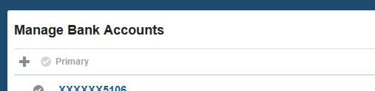

Add bank information and then hit “Save and Close”:

